Slide.Show 2 Configuration Guide
Vertigo Software
October 2008, Updated July & August 2009 by sbeeler
Contents
Introduction 3
Configuring your slideshow 3
Option 1: Using a theme 3
Option 2: Using an XML file 3
Configuration details (XML) 4
Configuration modules 4
Module element reference 5
Module options 8
General 8
Transition 8
DataProvider 9
Preloader 9
LoadingProgressIndicator 9
SlideNavigation 9
EmbedViewer 10
NavigationTray 11
ToggleAlbumViewButton 11
ToggleFullScreenButton 11
ToggleEmbedViewButton 12
ToggleSaveButton 12
SlideDescription 13
AlbumViewer 13
ThumbnailViewer 14
SlideThumbnail 14
AlbumPage 14
AlbumButton 14
SlidePreview 15
SlideViewer 15
VideoViewer 15
VideoTray 15
PeopleTag 16
Sample XML configuration file 16

Introduction
The purpose of this guide is to help you understand the available configuration options that allow you to customize the look and feel of your slideshow using Slide.Show 2.

Configuring your slideshow
To give substance to your slideshow, you’ll need to configure it. A configuration provider is specified via the initParams of your Slide.Show 2 object tag.
<param name="initParams" value="ConfigurationProvider=[configuration],DataProvider=..."/>
Slide.Show 2 provides you with the following options for configuration:
- Specify a theme
- Specify an XML file

Option 1: Using a theme
A theme is a set of values for the available configuration options that provide a consistent look and feel for a slideshow. Using a theme is the easiest way to configure your slideshow. The available out-of-the-box themes are: SimpleTheme, LightTheme, and DarkTheme.
To specify a theme, modify the initParams of your Slide.Show 2 object tag by replacing [configuration] with the desired theme. In the following example, we are specifying the LightTheme:
<param name="initParams" value="ConfigurationProvider=LightTheme,DataProvider=..."/>
Tip: In code, a theme is implemented as a class. To implement a custom theme, please refer to LightTheme.cs in the source code. Make a copy of the theme that most closely resembles your desired theme and make changes as appropriate in the desired regions. Then, open up App.xaml.cs and add your new theme to the case statement in InstantiateConfigurationProvider.

Option 2: Using an XML file
This option is available to those who want full control over the look and feel of their slideshow. Here you are to create an XML file, specifying the value of each option as desired.
To use XML configuration, modify the initParams of the Slide.Show 2 object tag by replacing [configuration] with XmlConfigurationProvider and the path to your XML configuration file. In the following example, we are using a file named Configuration.xml located in the same folder as the Slide.Show 2 XAP file:
<param name="initParams" value="ConfigurationProvider=XmlConfigurationProvider;Path=Configuration.xml,DataProvider=..."/>
Next, create a file named Configuration.xml containing the following markup:

<configuration background="Silver">
<module name="NavigationTray">
<option name="Enabled" value="true" />
<option name="BackgroundOpacity" value="1" />
<option name="Background" value="White" />
…
</module>
…
</configuration>

Modules represent a logical grouping of configuration options. Each module contains a set of options that specify the look and feel of their respective element/control. A full listing of modules is below.

Configuration details (XML)

Configuration modules
The following is a list of the available modules and a brief description of each one:
Module | Description
General | General options for the Slide Show
Transition | Transition timing related options
DataProvider | Controls the DataProvider type
Preloader | Controls the number of images to preload
LoadingProgressIndicator | Options for display of a “loading…” progress indicator
SlideNavigation | Displays UI to navigate between slides and to play/pause slides
EmbedViewer | Displays details for embedding the current slideshow
NavigationTray | Hosts the navigation elements for the slideshow
ToggleAlbumViewButton | The button used to show/hide the AlbumViewer
ToggleFullScreenButton | The button used to toggle full-screen mode
ToggleEmbedViewButton | The button used to show/hide the EmbedViewer
ToggleSaveButton | The button used to allow user to download the current image
SlideDescription | Displays basic information for the current slide
AlbumViewer | Displays the available albums
ThumbnailViewer | Displays a list of slide thumbnails
SlideThumbnail | Represents a thumbnail within the ThumbnailViewer
AlbumPage | Displays a page of albums
AlbumButton | Displays basic information for an album
SlidePreview | Displays the preview of a slide
SlideViewer | Includes option for how images should be stretched
VideoViewer | Includes option for automatically starting videos
VideoTray | Displays elements for interacting with a video

Module element reference
The following provides a visual reference to the available modules:
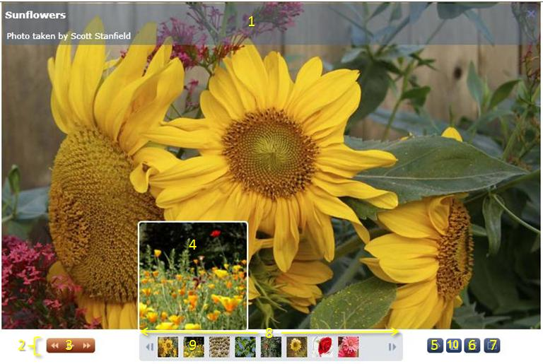
- SlideDescription
- NavigationTray
- SlideNavigation
- SlidePreview
- ToggleEmbedViewButton
- ToggleAlbumViewButton
- ToggleFullScreenButton
- ThumbnailViewer
- SlideThumbnail
- ToggleSaveButton

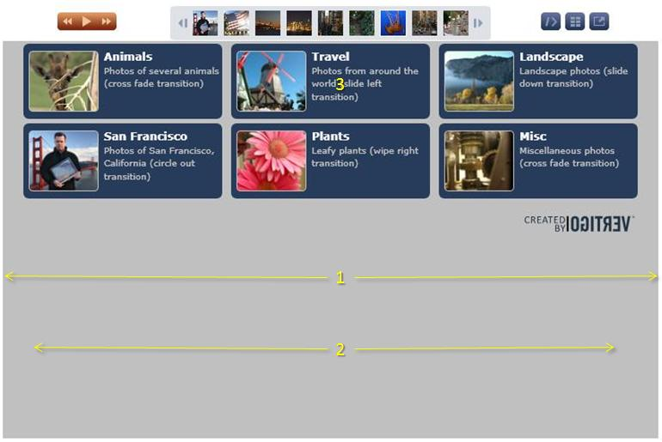

- AlbumViewer
- AlbumPage
- AlbumButton

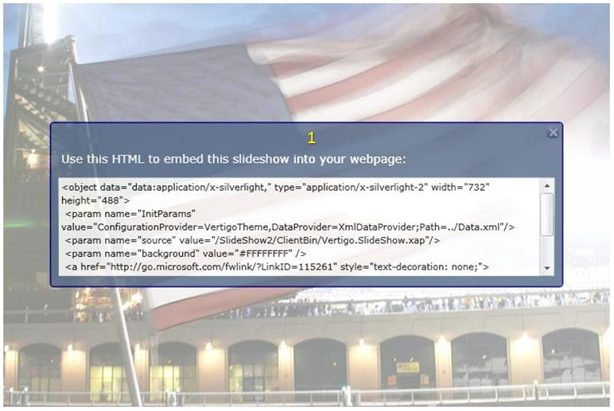

- EmbedViewer

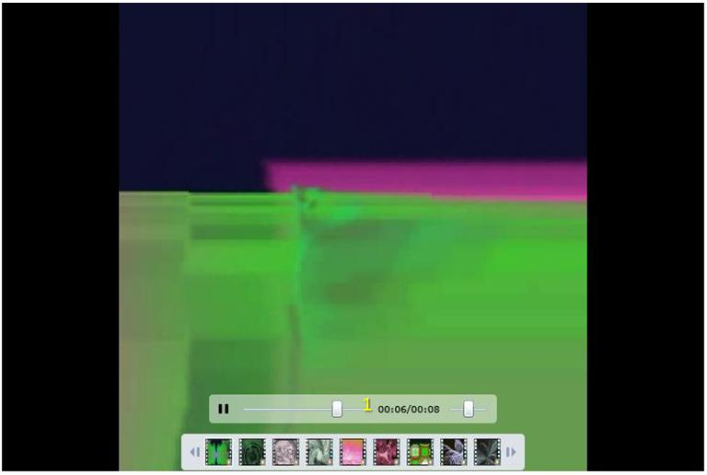

- VideoTray

Module options
The following is a list of the available options for each module:

General
Option | Type | Description
Background | Color | Background color
AutoStart | Boolean | Indicates if slide shows should start playing automatically when opened
StartInAlbumView | Boolean | Indicates if the slide show should start in album view by default

Transition
Option | Type | Description
TransitionDuration | Integer | The duration of each transition
WaitTime | Integer | The amount of time spent on each slide between transitions

DataProvider
Option | Type | Description
Type | String | DataProvider type. Valid values include FlickrDataProvider and XmlDataProvider
UserName | String | The Flickr username. Not used for XmlDataProvider.
ApiKey | String | The Flickr ApiKey. Not used for XmlDataProvider.
Uri | String | The Flickr Uri. Not used for XmlDataProvider.

Preloader
Option | Type | Description
PreloadAhead | Integer | The number of images to load ahead

LoadingProgressIndicator
Option | Type | Description
Enabled | Boolean | Indicates whether or not to display the element
Type | String | Valid options include “bar” and “circle”
Height | Integer | Height of the bar. Effectively ignored for circle.
Width | Integer | Width of the bar or the diameter of the circle.
Foreground | Color | Foreground color
Background | Color | Background color

SlideNavigation
Option | Type | Description
Enabled | Boolean | Indicates whether or not to display the element
PlayPathData | String | Abbreviated path markup for the visual
PausePathData | String | Abbreviated path markup for the visual
PreviousPathData | String | Abbreviated path markup for the visual
NextPathData | String | Abbreviated path markup for the visual
Foreground | Color | Color of the foreground
ForegroundHover | Color | Color of the hover of the foreground
Background1Brush | Color | Color of the background gradient
Background2Brush | Color | Color of the background gradient
RadiusX | Double | X radius of the corner
RadiusY | Double | Y radius of the corner
Width | Double | Width of the element
Height | Double | Height of the element
PlayPauseButtonWidth | Double | Width of the play/pause button
PlayPauseButtonHeight | Double | Height of the play/pause button
NextButtonWidth | Double | Width of the next button
NextButtonHeight | Double | Height of the next button
PreviousButtonWidth | Double | Width of the previous button
PreviousButtonHeight | Double | Height of the previous button
PlayPauseButtonPathWidth | Double | Width of the path for the play/pause button
PlayPauseButtonPathHeight | Double | Height of the path for the play/pause button
NextButtonPathWidth | Double | Width of the path for the next button
NextButtonPathHeight | Double | Height of the path for the next button
PreviousButtonPathWidth | Double | Width of the path of the previous button
PreviousButtonPathHeight | Double | Height of the path of the previous button

EmbedViewer
Option | Type | Description
Enabled | Boolean | Indicates whether or not to display the element
Background | Color | Color of the background
BackgroundOpacity | Double | Opacity of the background (0-1)
CornerRadius | Double | Radius of the corner (CornerRadius or Double)
DialogBackground | Color | Color of the background of the dialog
DialogBackgroundOpacity | Double | Opacity of the background of the dialog (0-1)
DialogBorderBrush | Color | Color of the border of the dialog
DialogBorderThickness | Double | Thickness of the border of the dialog
DialogWidth | Double | Width of the dialog
DialogHeight | Double | Height of the dialog
CloseButtonBackground1Brush | Color | Color of the background gradient
CloseButtonBackground2Brush | Color | Color of the background gradient
CloseButtonForegroundBrush | Color | Color of the close button
CloseButtonForegroundHoverBrush | Color | Color of the hover for the close button
CloseButtonRadiusX | Double | X radius of the close button corner
CloseButtonRadiusY | Double | Y radius of the close button corner
CloseButtonMargin | Double | Margin of the close button (Margin or Double)
CloseButtonWidth | Double | Width of the close button
CloseButtonHeight | Double | Height of the close button
CloseButtonPathWidth | Double | Width of the path for the close button
CloseButtonPathHeight | Double | Height of the path for the close button
CloseButtonPathData | String | Abbreviated path markup for the visual
HyperlinkButtonText | String | Text for the copy to clipboard link
HyperlinkButtonMargin | Double | Margin of the clipboard link (Margin or Double)
HyperlinkButtonForeground | Color | Color of the link foreground
HyperlinkButtonBackground | Color | Color of the link background
HyperlinkButtonWidth | Double | Width of the link
HyperlinkButtonHeight | Double | Height of the link
HyperlinkButtonFontFamily | String | Font of the link
HyperlinkButtonFontSize | Double | Font size of the link
TextBlockFontFamily | String | Font of the title text block
TextBlockFontSize | Double | Font size of the title text block
TitleText | String | Text to display in the title
TextBlockMargin | Double | Margin of the title text block (Margin or Double)
TextBlockForeground | Color | Color of the title text block
TextBoxWidth | Double | Width of the output text box
TextBoxHeight | Double | Height of the output text box
TextBoxFontFamily | String | Font of the output text block
TextBoxFontSize | Double | Font size of the output text block
TextBoxBackground | Color | Color of the background for the output text box
TextBoxForeground | Color | Color of the foreground for the output text box

NavigationTray
Option | Type | Description
Enabled | Boolean | Indicates whether or not to display the element
BackgroundOpacity | Double | Opacity of the background (0-1)
Background | Color | Color of the background

ToggleAlbumViewButton
Option | Type | Description
Enabled | Boolean | Indicates whether or not to display the element
Width | Double | Width of the element
Height | Double | Height of the element
PathWidth | Double | Width of the path visual
PathHeight | Double | Height of the path visual
PathData | String | Abbreviated path markup for the visual
Background1Brush | Color | Color of the background gradient
Background2Brush | Color | Color of the background gradient
ForegroundBrush | Color | Color of the foreground
ForegroundHoverBrush | Color | Color of the hover of the foreground
RadiusX | Double | X radius of the corner
RadiusY | Double | Y radius of the corner
Margin | Double | Margin of the element (Margin or Double)
Tooltip | String | Tooltip for the button. Set to empty string for no tooltip

ToggleFullScreenButton
Option | Type | Description
Enabled | Boolean | Indicates whether or not to display the element
Width | Double | Width of the element
Height | Double | Height of the element
PathWidth | Double | Width of the path visual
PathHeight | Double | Height of the path visual
PathData | String | Abbreviated path markup for the visual
Background1Brush | Color | Color of the background gradient
Background2Brush | Color | Color of the background gradient
ForegroundBrush | Color | Color of the foreground
ForegroundHoverBrush | Color | Color of the hover of the foreground
RadiusX | Double | X radius of the corner
RadiusY | Double | Y radius of the corner
Margin | Double | Margin of the element (Margin or Double)
RadiusY | Double | Y radius of the corner
GoToFullTooltip | Double | Tooltip for the enter full screen mode button.
EscapeFullTooltip | String | Tooltip for the escape full screen button.

ToggleEmbedViewButton
Option | Type | Description
Enabled | Boolean | Indicates whether or not to display the element
Width | Double | Width of the element
Height | Double | Height of the element
PathWidth | Double | Width of the path visual
PathHeight | Double | Height of the path visual
PathData | String | Abbreviated path markup for the visual
Background1Brush | Color | Color of the background gradient
Background2Brush | Color | Color of the background gradient
ForegroundBrush | Color | Color of the foreground
ForegroundHoverBrush | Color | Color of the hover of the foreground
RadiusX | Double | X radius of the corner
RadiusY | Double | Y radius of the corner
Margin | Double | Margin of the element (Margin or Double)
Tooltip | String | Tooltip for the button. Set to empty string for no tooltip

ToggleSaveButton
Option | Type | Description
Enabled | Boolean | Indicates whether or not to display the element
Width | Double | Width of the element
Height | Double | Height of the element
PathWidth | Double | Width of the path visual
PathHeight | Double | Height of the path visual
PathData | String | Abbreviated path markup for the visual
Background1Brush | Color | Color of the background gradient
Background2Brush | Color | Color of the background gradient
ForegroundBrush | Color | Color of the foreground
ForegroundHoverBrush | Color | Color of the hover of the foreground
RadiusX | Double | X radius of the corner
RadiusY | Double | Y radius of the corner
Margin | Double | Margin of the element (Margin or Double)
DownloadImageHandler | Double | Absolute URI to image download handler
Tooltip | String | Tooltip for the button. Set to empty string for no tooltip

SlideDescription
Option | Type | Description
Enabled | Boolean | Indicates whether or not to display the element
TitleHeight | Integer | Height of the title section of the element
TitleForeground | Color | Foreground color of the title
TitleBackground | Color | Background color of the title
TitleBackgroundOpacity | Double | Opacity of the title background (0-1)
TitleFontSize | Double | Font size of the title
TitleFontFamily | String | Font of the title
TitleMargin | Double | Margin of the title (Margin or Double)
DescriptionHeight | Integer | Height of the description section of the element
DescriptionForeground | Color | Foreground color of the description
DescriptionBackground | Color | Background color of the description
DescriptionBackgroundOpacity | Double | Opacity of the description background (0-1)
DescriptionFontSize | Double | Font size of the description
DescriptionFontFamily | String | Font of the description
DescriptionMargin | Double | Margin of the description (Margin or Double)
Background | Color | Background color
BackgroundOpacity | Double | Opacity of the background (0-1)
BackgroundRadiusX | Double | X radius of the background corner
BackgroundRadiusY | Double | Y radius of the background corner
BackgroundMargin | Double | Margin of the background (Margin or Double)
CloseButtonBackground1Brush | Color | Color of the background gradient
CloseButtonBackground2Brush | Color | Color of the background gradient
CloseButtonForegroundBrush | Color | Color of the foreground of the close button
CloseButtonForegroundHoverBrush | Color | Color of the hover of the close button
CloseButtonRadiusX | Double | X radius of the background corner
CloseButtonRadiusY | Double | Y radius of the background corner
CloseButtonMargin | Double | Margin of the close button (Margin or Double)
CloseButtonWidth | Double | Width of the close button
CloseButtonHeight | Double | Height of the close button
CloseButtonPathWidth | Double | Width of the path in the close button
CloseButtonPathHeight | Double | Height of the path in the close button
CloseButtonPathData | String | Abbreviated path markup for the visual

AlbumViewer
Option | Type | Description
Enabled | Boolean | Indicates whether or not to display the element
ScrollButtonForeground | Color | Color of the scroll button
ScrollButtonForegroundHover | Color | Color of the hover of the scroll button
ScrollButtonWidth | Double | Width of the scroll button
ScrollButtonHeight | Double | Height of the scroll button
ScrollButtonMargin | Double | Margin of the scroll button (Margin or Double)
LeftScrollButtonData | String | Abbreviated path markup for the visual
RightScrollButtonData | String | Abbreviated path markup for the visual
PageNumberFontSize | Double | Font size of the page number
PageNumberFontFamily | String | Font of the page number
PageNumberForeground | Color | Color of the page number

ThumbnailViewer
Option | Type | Description
Enabled | Boolean | Indicates whether or not to display the element
Background | Color | Color of the background
BackgroundOpacity | Double | Opacity of the background (0-1)
BackgroundRadiusX | Double | X radius of the background corner
BackgroundRadiusY | Double | Y radius of the background corner
Width | Double | Width of the element
Height | Double | Height of the element
Margin | Double | Margin of the element (Margin or Double)
ThumbSpacing | Double | Spacing between the thumbnails
ScrollIncrement | Double | Indicates how much space each scroll covers
ScrollButtonBrush | Color | Color of the scroll button
ScrollButtonHoverBrush | Color | Color of the hover of the scroll button
ScrollButtonWidth | Double | Width of the scroll button
ScrollButtonHeight | Double | Height of the scroll button
ScrollButtonMargin | Double | Margin of the scroll button (Margin or Double)
ScrollRepeatButtonInterval | Double | Indicates how fast the elements scroll
LeftScrollButtonData | String | Abbreviated path markup for the visual
RightScrollButtonData | String | Abbreviated path markup for the visual

SlideThumbnail
Option | Type | Description
Height | Double | Height of the element
BorderBrush | Color | Color of the border
BorderHighlightBrush | Color | Color of the highlight for the border
BorderThickness | Double | Thickness of the border (Thickness or Double)

AlbumPage
Option | Type | Description
Background | Color | Color of the background

AlbumButton
Option | Type | Description
Background | Color | Color of the background
BackgroundHover | Color | Color of the hover for the background
TitleFontSize | Double | Font size of the title
TitleFontFamily | String | Font of the title
TitleForeground | Color | Color of the title
TitleMargin | Double | Margin of the title (Margin or Double)
DescriptionFontSize | Double | Font size of the description
DescriptionFontFamily | String | Font of the description
DescriptionForeground | Color | Color of the description
DescriptionMargin | Double | Margin of the description (Margin or Double)
Width | Double | Width of the element
Height | Double | Height of the element
Padding | Double | Padding of the element
BackgroundRadiusX | Double | X radius of the background corner
BackgroundRadiusY | Double | Y radius of the background corner
ThumbnailWidth | Double | Width of the thumbnail
ThumbnailHeight | Double | Height of the thumbnail
ThumbnailRadiusX | Double | X radius of the thumbnail corner
ThumbnailRadiusY | Double | Y radius of the thumbnail corner
ThumbnailMargin | Double | Margin of the thumbnail (Margin or Double)
ThumbnailBorderStroke | Color | Color of the border for the thumbnail
ThumbnailBorderThickness | Double | Thickness of the border for the thumbnail

SlidePreview
Option | Type | Description
Enabled | Boolean | Indicates whether or not to display the element
Height | Double | Height of the element
BorderBrush | Color | Color of the border of the element
BorderWidth | Double | Width of the border of the element
RadiusX | Double | X radius of the corner of the element
RadiusY | Double | Y radius of the corner of the element

SlideViewer
Option | Type | Description
Stretch | Stretch | Type of Stretch that should be used when displaying images

VideoViewer
Option | Type | Description
AutoPlay | Boolean | Indicates if a video slide will play automatically

VideoTray
Option | Type | Description
Enabled | Boolean | Indicates whether or not to display the element
Width | Double | Width of the element
Height | Double | Height of the element
PlayPauseButtonWidth | Double | Width of the play/pause button
PlayPauseButtonHeight | Double | Height of the play/pause button
PlayPauseButtonPathWidth | Double | Width of the path for the play/pause button
PlayPauseButtonPathHeight | Double | Height of the path for the play/pause button
RadiusX | Double | X radius of the corner
RadiusY | Double | Y radius of the corner
Foreground | Color | Color of the foreground
ForegroundHover | Color | Color of the hover for the foreground
Background | Color | Color of the background
TextForegroundBrush | Color | Color of the text
TextFontSize | Double | Font size of the text
TextFontFamily | String | Font of the text
BackgroundOpacity | Double | Opacity of the background (0-1)
VolumeWidth | Double | Width of the volume element
PlayPathData | String | Abbreviated path markup for the visual
PausePathData | String | Abbreviated path markup for the visual
Margin | Thickness | Left, top, right, and bottom margins.

PeopleTag
Option | Type | Description
Enabled | Boolean | Indicates whether or not to display the element
PersonNameMargin | Thickness | Left, top, right, and bottom margins.
PersonNameForeground | Color | Color of the person name
PersonNameFontSize | Double | Font size of the person name
PersonNameFontFamily | String | Font of the person name
BackgroundBorderBrush | Color | Color of border around the tag
Background | Color | Background color of the tag
BackgroundBorderThickness | Thickness | Left, top, right, and bottom margins.
BackgroundCornerRadius | Double | Radius of the corner (CornerRadius or Double)
BackgroundOpacity | Double | Opacity of the background (0-1)

Sample XML configuration file
The following is a sample XML configuration file containing a full listing of all modules and options:
<configuration background="Silver" AutoStart="true" StartInAlbumView="false" >
<module name="Transition">
<option name="TransitionDuration" value="500" />
<option name="WaitTime" value="3000" />
</module>
<module name="DataProvider">
<option name="Type" value="FlickrDataProvider" />
</module>
<module name="Preloader">
<option name="PreloadAhead" value="5" />
</module>
<module name="LoadingProgressIndicator">
<option name="Enabled" value="true" />
<option name="Type" value="bar" />
<option name="Height" value="3" />
<option name="Width" value="75" />
<option name="Foreground" value="White" />
<option name="Background" value="Black" />
</module>
<module name="SlideNavigation">
<option name="Enabled" value="true" />
<option name="PlayPathData" value="F1 M 101.447,284.834L 101.447,274.714L 106.906,279.774L 101.447,284.834 Z" />
<option name="PausePathData" value="M 100.048,736.889L 98.5482,736.889C 97.9959,736.889 97.5482,736.441 97.5482,735.889L 97.5482,727.889C 97.5482,727.337 97.9959,726.889 98.5482,726.889L 100.048,726.889C 100.6,726.889 101.048,727.337 101.048,727.889L 101.048,735.889C 101.048,736.441 100.6,736.889 100.048,736.889 Z M 106.922,736.889L 105.422,736.889C 104.87,736.889 104.422,736.441 104.422,735.889L 104.422,727.889C 104.422,727.337 104.87,726.889 105.422,726.889L 106.922,726.889C 107.475,726.889 107.922,727.337 107.922,727.889L 107.922,735.889C 107.922,736.441 107.475,736.889 106.922,736.889 Z" />
<option name="PreviousPathData" value="F1 M6.0000005,1.473075E-06 L6.0000005,10.000002 5.9604696E-07,5.0000014 6.0000005,1.473075E-06 z M-1.3709068E-06,4.0019114E-07 L-1.3709068E-06,10.000006 -6.0000029,5.0000029 -1.3709068E-06,4.0019114E-07 Z" />
<option name="NextPathData" value="F1 M-5.9999976,1.0552602E-05 L-1.9073478E-06,4.9999938 -1.9073478E-06,1.8062785E-05 5.9999981,5.0000033 -1.9073478E-06,10.000018 -1.9073478E-06,5.0000024 -5.9999976,9.9999857 -5.9999976,1.0552602E-05 Z" />
<option name="Foreground" value="#F2C29F" />
<option name="ForegroundHover" value="White" />
<option name="Background1Brush" value="#7F2D12" />
<option name="Background2Brush" value="#E9A16B" />
<option name="RadiusX" value="4" />
<option name="RadiusY" value="4" />
<option name="Width" value="66" />
<option name="Height" value="20" />
<option name="PlayPauseButtonWidth" value="22" />
<option name="PlayPauseButtonHeight" value="20" />
<option name="NextButtonWidth" value="22" />
<option name="NextButtonHeight" value="20" />
<option name="PreviousButtonWidth" value="22" />
<option name="PreviousButtonHeight" value="20" />
<option name="PlayPauseButtonPathWidth" value="10" />
<option name="PlayPauseButtonPathHeight" value="12" />
<option name="NextButtonPathWidth" value="10" />
<option name="NextButtonPathHeight" value="8" />
<option name="PreviousButtonPathWidth" value="10" />
<option name="PreviousButtonPathHeight" value="8" />
</module>
<module name="EmbedViewer">
<option name="Enabled" value="true" />
<option name="Background" value="Silver" />
<option name="BackgroundOpacity" value=".5" />
<option name="CornerRadius" value="4" />
<option name="DialogBackground" value="#536987" />
<option name="DialogBackgroundOpacity" value=".8" />
<option name="DialogBorderBrush" value="#000080" />
<option name="DialogBorderThickness" value="2" />
<option name="DialogWidth" value="620" />
<option name="DialogHeight" value="200" />
<option name="CloseButtonBackground1Brush" value="#273B5B" />
<option name="CloseButtonBackground2Brush" value="#6A75A2" />
<option name="CloseButtonForegroundBrush" value="#8D9AB4" />
<option name="CloseButtonForegroundHoverBrush" value="White" />
<option name="CloseButtonRadiusX" value="4" />
<option name="CloseButtonRadiusY" value="4" />
<option name="CloseButtonMargin" value="3" />
<option name="CloseButtonWidth" value="15" />
<option name="CloseButtonHeight" value="15" />
<option name="CloseButtonPathWidth" value="10" />
<option name="CloseButtonPathHeight" value="10" />
<option name="CloseButtonPathData" value="M59.156,59.156 L81.073,81.073 C81.073,81.073 82.635,85.167 81.07,86.729 L26.573,141.228 L84.072,198.728 C85.634,200.290 85.634,202.822 84.072,204.384 L62.155,226.301 C60.593,227.863 58.061,227.863 56.499,226.301 L-1.000,168.801 L-57.499,225.301 C-59.061,226.863 -61.593,226.863 -63.155,225.301 L-85.072,203.384 C-86.634,201.822 -86.634,199.290 -85.072,197.728 L-28.573,141.228 L-82.073,87.729 C-83.635,86.167 -83.635,83.635 -82.073,82.073 L-60.156,60.156 C-58.594,58.594 -56.062,58.594 -54.500,60.156 L-1.000,113.655 L53.500,59.156 C55.062,57.594 57.594,57.594 59.156,59.156 z" />
<option name="HyperlinkButtonText" value="Copy to clipboard [xml]"/>
<option name="HyperlinkButtonForeground" value="White"/>
<option name="HyperlinkButtonBackground" value="#536987"/>
<option name="HyperlinkButtonMargin" value="12"/>
<option name="HyperlinkButtonWidth" value="200"/>
<option name="HyperlinkButtonHeight" value="20"/>
<option name="HyperlinkButtonFontSize" value="14"/>
<option name=" HyperlinkButtonFontFamily" value="Portable User Interface" />
<option name="TextBlockFontSize" value="14" />
<option name="TextBlockFontFamily" value="Portable User Interface" />
<option name="TitleText" value="Use this HTML to embed this slideshow into your webpage:" />
<option name="TextBlockMargin" value="12" />
<option name="TextBlockForeground" value="White" />
<option name="TextBoxWidth" value="600" />
<option name="TextBoxHeight" value="120" />
<option name="TextBoxBackground" value="White" />
<option name="TextBoxForeground" value="Black" />
<option name="TextBoxFontSize" value="14" />
<option name="TextBoxFontFamily" value="Portable User Interface" />
</module>
<module name="NavigationTray">
<option name="Enabled" value="true" />
<option name="BackgroundOpacity" value-="1" />
<option name="Background" value="White" />
</module>
<module name="ToggleAlbumViewButton">
<option name="Enabled" value="true" />
<option name="Width" value="22" />
<option name="Height" value="20" />
<option name="PathWidth" value="11" />
<option name="PathHeight" value="11" />
<option name="PathData" value="M0.3068684,6.6970766E-23 L4.8691305,6.6970766E-23 C5.0380702,3.6356173E-08 5.1759998,0.13792887 5.1759998,0.30690225 L5.1759998,2.6368366 C5.1759998,2.8058099 5.0380702,2.9437565 4.8691305,2.9437565 L0.3068684,2.9437565 C0.13680684,2.9437565 1.2251062E-13,2.8058099 -3.3276147E-30,2.6368366 L-3.3276147E-30,0.30690225 C1.2251062E-13,0.13792887 0.13680684,3.6356173E-08 0.3068684,6.6970766E-23 z M6.5989051,3.4025645E-07 L11.162244,3.4025645E-07 C11.331214,2.5640611E-07 11.468,0.13793494 11.468,0.30690496 L11.468,2.6368515 C11.468,2.8058217 11.331214,2.9437562 11.162244,2.9437562 L6.5989051,2.9437562 C6.4299352,2.9437562 6.2920002,2.8058217 6.2920002,2.6368515 L6.2920002,0.30690496 C6.2920002,0.13793494 6.4299352,2.5640611E-07 6.5989051,3.4025645E-07 z M0.30690471,4.0560001 L4.8690952,4.0560001 C5.0380656,4.0560001 5.1760002,4.1927856 5.1760002,4.3617556 L5.1760002,6.6928522 C5.1760002,6.861822 5.0380656,6.9997566 4.8690952,6.9997566 L0.30690471,6.9997566 C0.1367853,6.9997566 4.0662732E-08,6.861822 -3.3276153E-30,6.6928522 L-3.3276153E-30,4.3617556 C4.0662732E-08,4.1927856 0.1367853,4.0560001 0.30690471,4.0560001 z M6.5989051,4.0560005 L11.162244,4.0560005 C11.331214,4.0560005 11.468,4.192786 11.468,4.3617559 L11.468,6.6928519 C11.468,6.8618216 11.331214,6.9997562 11.162244,6.9997562 L6.5989051,6.9997562 C6.4299352,6.9997562 6.2920002,6.8618216 6.2920002,6.6928519 L6.2920002,4.3617559 C6.2920002,4.192786 6.4299352,4.0560005 6.5989051,4.0560005 z M0.30690471,8.1120001 L4.8690952,8.1120001 C5.0380656,8.1120001 5.1760002,8.2487856 5.1760002,8.4177556 L5.1760002,10.748852 C5.1760002,10.917822 5.0380656,11.055757 4.8690952,11.055757 L0.30690471,11.055757 C0.1367853,11.055757 4.0662732E-08,10.917822 -3.3276153E-30,10.748852 L-3.3276153E-30,8.4177556 C4.0662732E-08,8.2487856 0.1367853,8.1120001 0.30690471,8.1120001 z M6.5989051,8.1120005 L11.162244,8.1120005 C11.331214,8.1120005 11.468,8.248786 11.468,8.4177559 L11.468,10.748852 C11.468,10.917822 11.331214,11.055756 11.162244,11.055756 L6.5989051,11.055756 C6.4299352,11.055756 6.2920002,10.917822 6.2920002,10.748852 L6.2920002,8.4177559 C6.2920002,8.248786 6.4299352,8.1120005 6.5989051,8.1120005 Z" />
<option name="Background1Brush" value="#273B5B" />
<option name="Background2Brush" value="#6A75A2" />
<option name="ForegroundBrush" value="#8D9AB4" />
<option name="ForegroundHoverBrush" value="White" />
<option name="RadiusX" value="4" />
<option name="RadiusY" value="4" />
<option name="Margin" value="0,0,5,0" />
<option name="Tooltip" value="Toggle album view" />
</module>
<module name="ToggleFullScreenButton">
<option name="Enabled" value="true" />
<option name="Width" value="22" />
<option name="Height" value="20" />
<option name="PathWidth" value="12" />
<option name="PathHeight" value="10" />
<option name="GoToFullPathData" value="M 7.90548,1.32341L 14.6458,1.32341L 14.6458,8.02661L 12.3811,5.78146L 8.43281,9.72004L 6.21009,7.42345L 10.1668,3.57935L 7.90548,1.32341 Z M -1.60064e-007,1.35265L 6.66667,1.35265L 6.66667,2.68583L 1.32284,2.68583L 1.32284,13.3317L 13.323,13.3317L 13.323,9.33174L 14.6562,9.33174L 14.6562,13.6585L 14.6458,13.6585L 14.6458,14.6963L -8.30604e-007,14.6963L -2.59563e-008,14.6651L -8.30604e-007,13.3317L -1.60064e-007,2.68583L -2.59563e-008,2.32351L -1.60064e-007,1.35265 Z" />
<option name="EscapeFullPathData" value="M 12.9504,9.72004L 6.21009,9.72004L 6.21009,3.01684L 8.47481,5.26199L 12.4231,1.32341L 14.6458,3.62L 10.6891,7.4641L 12.9504,9.72004 Z M 3.51898e-007,1.35265L 6.66667,1.35265L 6.66667,2.68583L 1.32284,2.68583L 1.32284,13.3317L 13.323,13.3317L 13.323,9.33174L 14.6562,9.33174L 14.6562,13.6585L 14.6458,13.6585L 14.6458,14.6963L -1.79383e-006,14.6963L 3.51898e-007,14.6651L -1.79383e-006,13.3317L 3.51898e-007,2.68583L 3.51898e-007,2.32351L 3.51898e-007,1.35265 Z" />
<option name="Background1Brush" value="#273B5B" />
<option name="Background2Brush" value="#6A75A2" />
<option name="ForegroundBrush" value="#8D9AB4" />
<option name="ForegroundHoverBrush" value="White" />
<option name="RadiusX" value="4" />
<option name="RadiusY" value="4" />
<option name="Margin" value="0" />
<option name="GoToFullTooltip" value="Switch to full-screen mode" />
<option name="EscapeFullTooltip" value="Exit full-screen mode" />
</module>
<module name="ToggleEmbedViewButton">
<option name="Enabled" value="true" />
<option name="Width" value="22" />
<option name="Height" value="20" />
<option name="PathWidth" value="13" />
<option name="PathHeight" value="11" />
<option name="PathData" value="M14.863486,7.5777659 L17.268641,8.2222252 L14.359774,19.078266 L11.954618,18.433807 L14.863486,7.5777659 z M21.529634,7.5262961 L27.602283,13.599229 L26.256895,14.944682 L26.256739,14.944526 L21.529394,19.672092 L20.184,18.326633 L24.911343,13.599068 L20.184246,8.871748 L21.529634,7.5262961 z" />
<option name="Background1Brush" value="#273B5B" />
<option name="Background2Brush" value="#6A75A2" />
<option name="ForegroundBrush" value="#8D9AB4" />
<option name="ForegroundHoverBrush" value="White" />
<option name="RadiusX" value="4" />
<option name="RadiusY" value="4" />
<option name="Margin" value="0,0,5,0" />
<option name="Tooltip" value="View html to embed this slideshow into your webpage" />
</module>
<module name="ToggleSaveButton">
<option name="Enabled" value="true" />
<option name="Width" value="22" />
<option name="Height" value="20" />
<option name="PathWidth" value="11" />
<option name="PathHeight" value="11" />
<option name="PathData" value="M13.303991,13.31762 L1.3528529,13.379672 L1.3085877,2.6726847 L4.4928222,2.6820953 L4.5800614,8.2556801 L10.643193,8.1718283 L10.643193,2.6820953 L13.391231,2.6328566 L13.303991,7.8029037 z M3.51898E-07,1.35265 L13.378687,1.3034161 L13.378687,2.6365962 L1.32284,2.6858301 L1.3664342,13.469897 L5.4088349,13.416098 L5.4112124,10.070662 L7.8303814,10.067492 L7.895155,13.465336 L13.347611,13.514574 L13.317558,1.3034161 L14.650759,1.3034161 L14.6562,13.6585 L14.6458,13.6585 L14.6458,14.6963 L-1.7938301E-06,14.6963 L3.51898E-07,14.6651 L-1.7938301E-06,13.3317 L3.51898E-07,2.6858301 L3.51898E-07,2.3235099 L3.51898E-07,1.35265 z" />
<option name="Background1Brush" value="#273B5B" />
<option name="Background2Brush" value="#6A75A2" />
<option name="ForegroundBrush" value="#8D9AB4" />
<option name="ForegroundHoverBrush" value="White" />
<option name="RadiusX" value="4" />
<option name="RadiusY" value="4" />
<option name="Margin" value="0,0,5,0" />
<option name="DownloadImageHandler" value="http://www.yourDomainHere.com/your_Path_Here/DownloadImage.ashx?image=" />
<option name="Tooltip" value="Download the current image" />
</module>
<module name="SlideDescription">
<option name="Enabled" value="true" />

<option name="TitleHeight" value="30" />
<option name="TitleForeground" value="White" />
<option name="TitleBackground" value="Black" />
<option name="TitleBackgroundOpacity" value="0" />
<option name="TitleFontFamily" value="Portable User Interface" />
<option name="TitleFontSize" value="13" />
<option name="TitleMargin" value="5, 8, 0, 0" />

<option name="DescriptionHeight" value="30" />
<option name="DescriptionForeground" value="White" />
<option name="DescriptionBackground" value="DarkGray" />
<option name="DescriptionBackgroundOpacity" value="0" />
<option name="DescriptionFontFamily" value="Portable User Interface" />
<option name="DescriptionFontSize" value="11" />
<option name="DescriptionMargin" value="6.5, 8, 0, 0" />

<option name="Background" value="#536987" />
<option name="BackgroundOpacity" value=".5" />
<option name="BackgroundRadiusX" value="4" />
<option name="BackgroundRadiusY" value="4" />
<option name="BackgroundMargin" value="2" />

<option name="CloseButtonBackground1Brush" value="Transparent" />
<option name="CloseButtonBackground2Brush" value="Transparent" />
<option name="CloseButtonForegroundBrush" value="#6A75A2" />
<option name="CloseButtonForegroundHoverBrush" value="White" />
<option name="CloseButtonRadiusX" value="4" />
<option name="CloseButtonRadiusY" value="4" />
<option name="CloseButtonMargin" value="3,-2,5,3" />
<option name="CloseButtonWidth" value="15" />
<option name="CloseButtonHeight" value="15" />
<option name="CloseButtonPathWidth" value="10" />
<option name="CloseButtonPathHeight" value="10" />
<option name="CloseButtonPathData" value="M59.156,59.156 L81.073,81.073 C81.073,81.073 82.635,85.167 81.07,86.729 L26.573,141.228 L84.072,198.728 C85.634,200.290 85.634,202.822 84.072,204.384 L62.155,226.301 C60.593,227.863 58.061,227.863 56.499,226.301 L-1.000,168.801 L-57.499,225.301 C-59.061,226.863 -61.593,226.863 -63.155,225.301 L-85.072,203.384 C-86.634,201.822 -86.634,199.290 -85.072,197.728 L-28.573,141.228 L-82.073,87.729 C-83.635,86.167 -83.635,83.635 -82.073,82.073 L-60.156,60.156 C-58.594,58.594 -56.062,58.594 -54.500,60.156 L-1.000,113.655 L53.500,59.156 C55.062,57.594 57.594,57.594 59.156,59.156 z" />
</module>
<module name="AlbumViewer">
<option name="Enabled" value="true" />
<option name="ScrollButtonForeground" value="#777" />
<option name="ScrollButtonForegroundHover" value="White" />
<option name="ScrollButtonWidth" value="10" />
<option name="ScrollButtonHeight" value="10" />
<option name="ScrollButtonMargin" value="5" />
<option name="LeftScrollButtonData" value="M0.05,0.8 C0.05,0.4 0.4,0.05 0.8,0.05 L2.7,0 C3.2,0 3.5,0.4 3.5,0.8 L3.5,9.2 C3.5,9.6 3.2,10 2.7,10 L0.8,10 C0.4,10 0,9.6 0,9.2 z M-3.4,0 L-9.4,5 -3.4,10 Z" />
<option name="RightScrollButtonData" value="M0,0.8 C0.05,0.4 0.4,0.05 0.8,0.05 L2.7,0 C3.2,0 3.5,0.4 3.5,0.8 L3.5,9.2 C3.5,9.6 3.2,10 2.7,10 L0.8,10 C0.4,10 0,9.6 0,9.2 z M6.9,0 L13,5 6.9,10 Z" />
<option name="PageNumberFontFamily" value="Portable User Interface" />
<option name="PageNumberFontSize" value="14" />
<option name="PageNumberForeground" value="White" />
</module>
<module name="ThumbnailViewer">
<option name="Enabled" value="true" />
<option name="Background" value="#DEE1E5" />
<option name="BackgroundOpacity" value="1" />
<option name="BackgroundRadiusX" value="4" />
<option name="BackgroundRadiusY" value="4" />
<option name="Width" value="310" />
<option name="Margin" value="5" />
<option name="ThumbSpacing" value="5" />
<option name="ScrollIncrement" value="310" />
<option name="ScrollButtonBrush" value="#8D9AB4" />
<option name="ScrollButtonHoverBrush" value="White" />
<option name="ScrollButtonWidth" value="10" />
<option name="ScrollButtonHeight" value="10" />
<option name="ScrollButtonMargin" value="5" />
<option name="ScrollRepeatButtonInterval" value="75" />
<option name="LeftScrollButtonData" value="M0.05,0.8 C0.05,0.4 0.4,0.05 0.8,0.05 L2.7,0 C3.2,0 3.5,0.4 3.5,0.8 L3.5,9.2 C3.5,9.6 3.2,10 2.7,10 L0.8,10 C0.4,10 0,9.6 0,9.2 z M-3.4,0 L-9.4,5 -3.4,10 Z" />
<option name="RightScrollButtonData" value="M0,0.8 C0.05,0.4 0.4,0.05 0.8,0.05 L2.7,0 C3.2,0 3.5,0.4 3.5,0.8 L3.5,9.2 C3.5,9.6 3.2,10 2.7,10 L0.8,10 C0.4,10 0,9.6 0,9.2 z M6.9,0 L13,5 6.9,10 Z" />
</module>
<module name="SlideThumbnail">
<option name="Height" value="28" />
<option name="BorderBrush" value="Transparent" />
<option name="BorderHighlightBrush" value="White" />
<option name="BorderThickness" value="1" />
</module>
<module name="AlbumPage">
<option name="Background" value="Silver" />
</module>
<module name="AlbumButton">
<option name="Background" value="#273B5B" />
<option name="BackgroundHover" value="#6A75A2" />
<option name="TitleFontFamily" value="Portable User Interface" />
<option name="TitleFontSize" value="12" />
<option name="TitleForeground" value="#F3F4F8" />
<option name="TitleMargin" value="0,6,0,0" />
<option name="DescriptionFontFamily" value="Portable User Interface" />
<option name="DescriptionFontSize" value="10" />
<option name="DescriptionForeground" value="Silver" />
<option name="DescriptionMargin" value="0" />
<option name="Width" value="222" />
<option name="Height" value="84" />
<option name="Padding" value="5" />
<option name="BackgroundRadiusX" value="6" />
<option name="BackgroundRadiusY" value="6" />
<option name="ThumbnailWidth" value="78" />
<option name="ThumbnailHeight" value="68" />
<option name="ThumbnailRadiusX" value="4" />
<option name="ThumbnailRadiusY" value="4" />
<option name="ThumbnailMargin" value="6" />
<option name="ThumbnailBorderStroke" value="Silver" />
<option name="ThumbnailBorderThickness" value="1" />
</module>
<module name="SlidePreview">
<option name="Enabled" value="true" />
<option name="Height" value="150" />
<option name="BorderBrush" value="White" />
<option name="BorderWidth" value="2" />
<option name="RadiusX" value="4" />
<option name="RadiusY" value="4" />
</module>
<module name="SlideViewer">
<option name="Stretch" value="Uniform" />
</module>
<module name="ImageViewer">
</module>
<module name="VideoViewer">
<option name="AutoPlay" value="true" />
</module>
<module name="VideoTray">
<option name="Enabled" value="true" />
<option name="Width" value="400" />
<option name="Height" value="30" />
<option name="Margin" value="0,-6,0,0" />
<option name="PlayPauseButtonWidth" value="20" />
<option name="PlayPauseButtonHeight" value="20" />
<option name="PlayPauseButtonPathWidth" value="10" />
<option name="PlayPauseButtonPathHeight" value="10" />
<option name="RadiusX" value="4" />
<option name="RadiusY" value="4" />
<option name="Foreground" value="Black" />
<option name="ForegroundHover" value="White" />
<option name="Background" value="White" />
<option name="TextForegroundBrush" value="Black" />
<option name="TextFontFamily" value="Portable User Interface" />
<option name="TextFontSize" value="10" />
<option name="BackgroundOpacity" value="0.5" />
<option name="VolumeWidth" value="50" />
<option name="PlayPathData" value="F1 M 101.447,284.834L 101.447,274.714L 106.906,279.774L 101.447,284.834 Z" />
<option name="PausePathData" value="M 100.048,736.889L 98.5482,736.889C 97.9959,736.889 97.5482,736.441 97.5482,735.889L 97.5482,727.889C 97.5482,727.337 97.9959,726.889 98.5482,726.889L 100.048,726.889C 100.6,726.889 101.048,727.337 101.048,727.889L 101.048,735.889C 101.048,736.441 100.6,736.889 100.048,736.889 Z M 106.922,736.889L 105.422,736.889C 104.87,736.889 104.422,736.441 104.422,735.889L 104.422,727.889C 104.422,727.337 104.87,726.889 105.422,726.889L 106.922,726.889C 107.475,726.889 107.922,727.337 107.922,727.889L 107.922,735.889C 107.922,736.441 107.475,736.889 106.922,736.889 Z" />
</module>
<module name="LoadingProgressIndicator">
<option name="Enabled" value="true" />
<option name="Margin" value="30,5,30,5" />
<option name="PersonNameForeground" value="Black" />
<option name="PersonNameFontFamily" value="Portable User Interface" />
<option name="PersonNameFontSize" value="12" />
<option name="BackgroundBorderBrush" value="Black" />
<option name="Background" value="WhiteSmoke" />
<option name="BackgroundBorderThickness" value="1" />
<option name="BackgroundBorderRadius" value="12" />
<option name="BackgroundOpacity" value="0.8" />
</module>
</configuration>

